**Exercise**

조건을 만족하는 피타고라스 수를 구한 뒤, 연산하는 문제입니다.

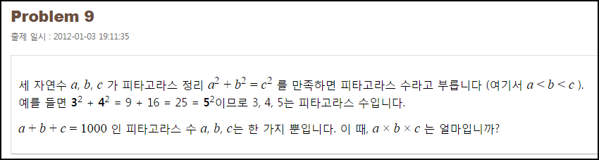

**Solution_code**

|  |  |  |
| --- | --- | --- |
| **1**  **2**  **3**  **4**  **5**  **6**  **7**  **8**  **9**  **10** | **for a in range(1,1000):**  **for b in range(1,1000):**  **a_2 = a**2**  **b_2 = b**2**  **c = 1000-a-b**  **if a_2 + b_2 == c**2:**  **if a+b+c == 1000:**  **print "[+] SUCCESS!!!!", a,b,c, a*b*c**    ***[Colored by Color Scripter](http://colorscripter.com/info#e)*** | [cs](http://colorscripter.com/info#e) |

.

**Result**

